## QUESTION 1

The following questions refer to the VB.NET solution caned Employee 1.4 NOV 2012\Question  that has been saved on the hard drive.

ABC Company employs fulltime and casual employees. Fulltime employees earn a monthly salary and casual employees earn a weekly wage. Casual employees substitute for fulltime employees when they are not at work. Casual employees are paid a fixed rate per hour. Design an application that calculates the monthly salary or weekly wage of an

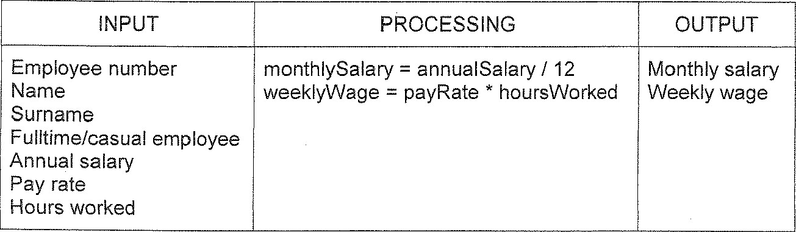

Below

is

the

fPO-chart

for

the

problem:

The following STEPS explain how to use the program to calculate the monthlySalary or weeklyWage of an employee:

STEP 1 RUN the program and enter the employee details.

E•ržpioyee Details. 

 Number:

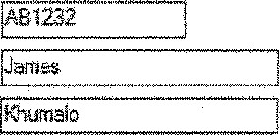Name: Idamee,

Surname: ithumaio

Select fulltime employee and enter the annual salary of the fulltime employee.

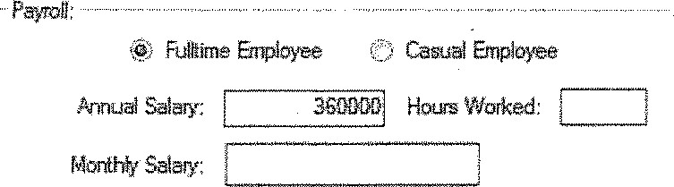

-5- 

or select casual employee and enter the pay rate per hour and the hours worked for the casual employee.

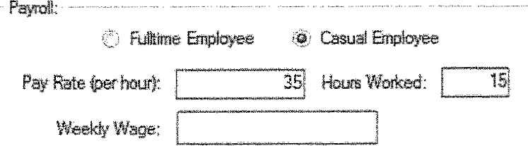

STEP 2 Click on the Process Payment button to calculate the monthly salary or weekly wage of an employee.

|  |  |  |
| --- | --- | --- |
| |  | | --- | | ecocess Payment | |  |

FIGURE 1 below is a print screen of what the user interface looks like. The completed interface has been saved on the hard disk.

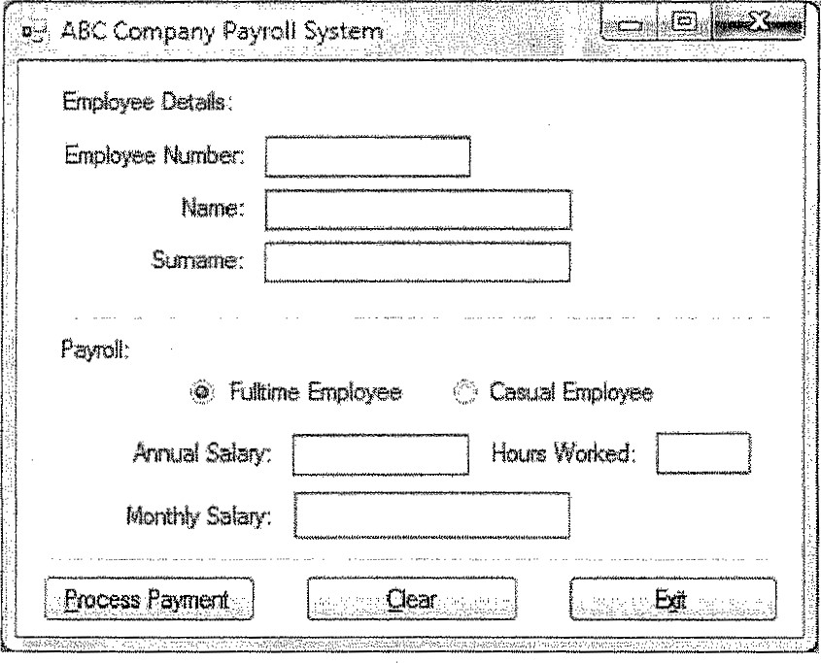

### FIGURE 1

Below are the class diagrams of the base/parent class (Employee) and the twoderived/child classes (casualEmployee and fulltimeEmployee). Study the class diagrams and answer questions (1.1 —

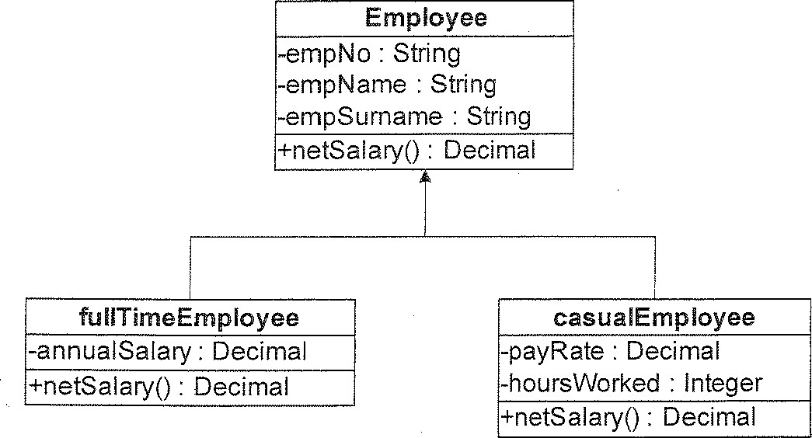

Open the solution Employee and follow the instructions to complete the program. The base class clsEmployee.vb has been added to the project.

1 . 1 Add the following program code to the Employee class:

Add your examination number to the program code.

1 . 1 . 1 Declare the private variables/fields for the Employee class.

1 .1 2 Create a default constructor for the Employee class. (1 )

1 .1 .3 Create all the public properties for the Employee class. (1 )

1 .1 .4 Create the netSala1Y() method for the Employee class. (1 )

1 .2 Create the fullTimeEmployee and casualEmployee derived classes. Add all

the fields, properties and methods to the classes.

Make a printout of the source code of all THREE classes.

1 .3 Add the folowing program code to the main form of the program:

 Add your examination number to the program code.

Create a fulltime and a casual employee object. (4)

1 .3.2 Add the following program code to the Click Event of the Process Payment button:

1. If the Fulltime Employee radio button has been selected, assign the values from the text boxes to the appropriate properties of the fullTimeEmp/oyee object. Call the netSalary method of the fullTimeEmployee class to calculate the monthly salary of a fulltime employee and display the answer in the appropriate label. (3)
2. If the Casual Employee radio button has been selected, assign the values from the text boxes to the appropriate properties of the casualEmployee object. Call the netSalary method of the casualEmployee class to calculate the monthly salary of a casual employee and display the answer in the appropriate label. (3)

Make a printout of the source code.

Change the text in the title bar of the Form to your examination number.

1 .4.1 Run the program, enter the following test data and print the form:

Employee number: AB 1223

Name: Sipho

Surname: Nkosi

Fulltime employee

Annual salary: R360 000 per year

1.4.2 Run the program again, enter the following test data and print the form:

Employee number: BB2322

Name: Josephine

Surname: Nkakula

Casual employee

Pay rate: R24.00 per hour

Hours worked: 15 (1)